[**https://pagespeed.web.dev/analysis/https-rasa-ma/zor1qa7obe?form_factor=mobile**](https://pagespeed.web.dev/analysis/https-rasa-ma/zor1qa7obe?form_factor=mobile)

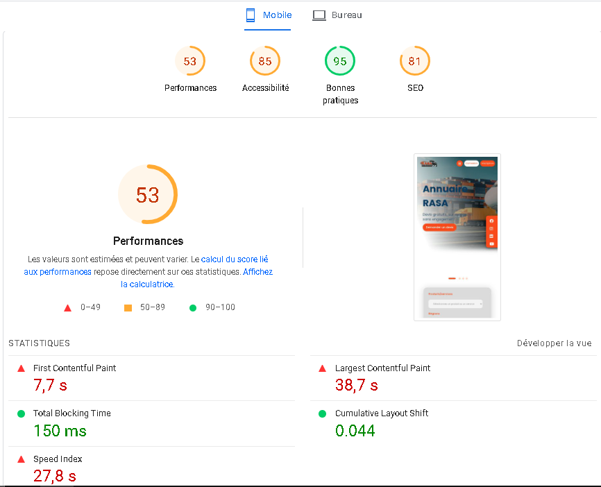

* **language or framework the site is symfony and twig and OTHER.**

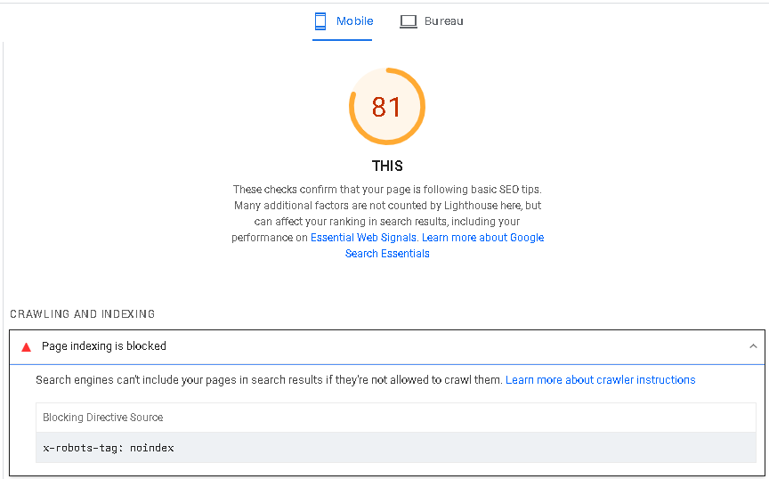

1. **Header Problem, we need to put meta titles and meta description for every page.**
2. **Screaming frog said that we have No-index tags on pages, please Remove no index tags from pages.**
3. **Change URL Structure ( we need to put a new slug for every page -I prepared the slugs for you -)**

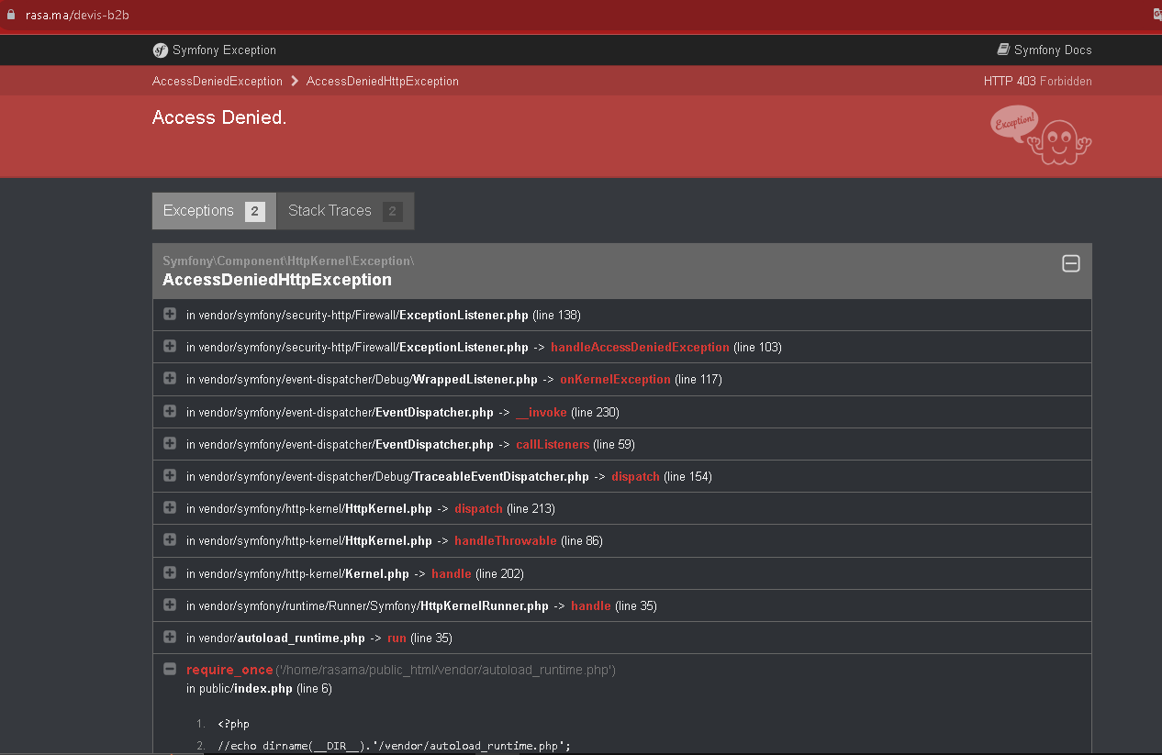

* **the particular session refuses :**

**https://rasa.ma/devis-b2b**

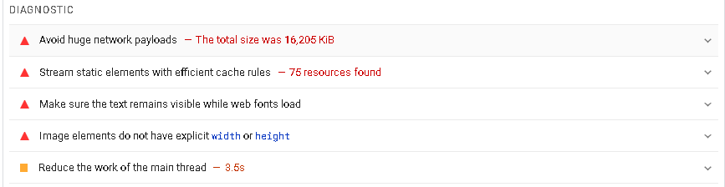

1. **Avoid huge network payloads The total size was**
2. **Stream static elements with efficient cache rules**
3. **Make sure the text remains visible while web fonts load**
4. **Image elements do not have explicit width or height**
5. **Reduce the work of the main thread**

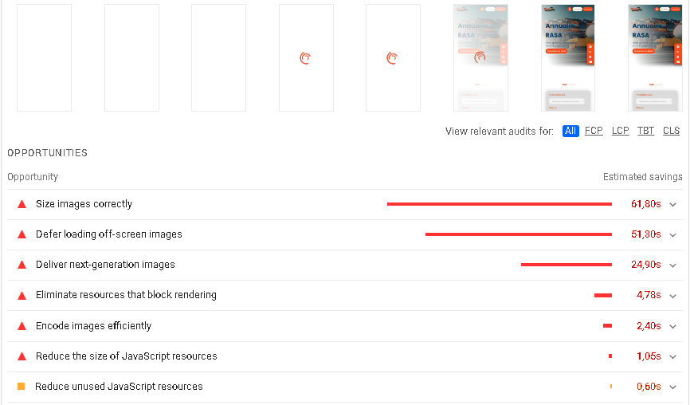

1. **Size images correctly**
2. **Defer loading off-screen images**
3. **Deliver next-generation images**
4. **Eliminate resources that block rendering**
5. **Encode images efficiently**
6. **Reduce the size of JavaScript resources**
7. **Reduce unused JavaScript resources**

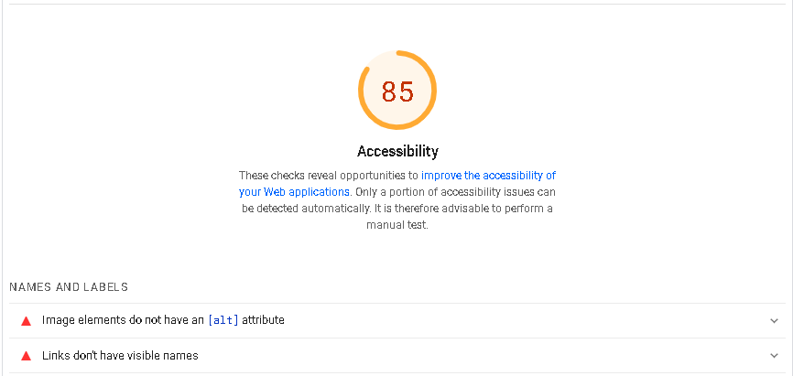

1. **Image elements do not have an [alt] attribute**

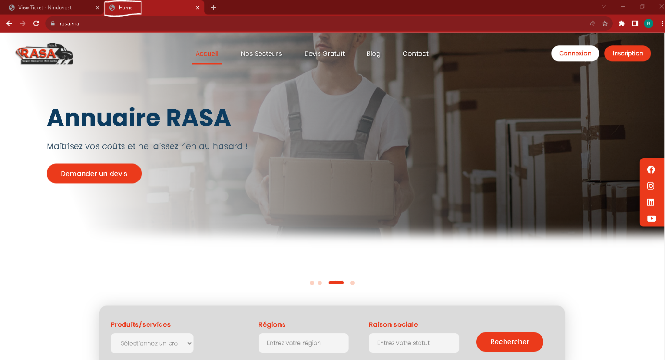

* **Favicon integration**